**PROJECT TITLE:**

**Automation of Gif+Export+Overview+Backup+Crop**

**using Work- Fusion**

1. Firstly, user has to check whether the gif Automation folder exists in E drive or not. Folder must consist of two different .xlsx documents. User has to open gif_caseid.xlsx file
2. User has to make entry in gif.xlsx file.

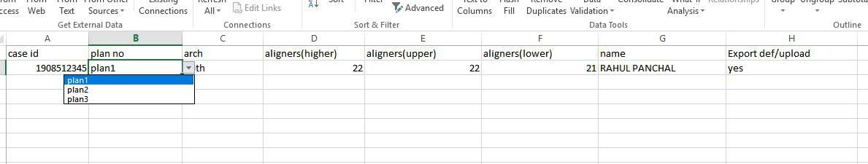

1. Entries of excel sheet are starting from A2. Case-id of patient is filled in A column. The case-id should be numeric with ten digits.
2. User must follow the following protocol to make appropriate entries in excel sheet.
   1. If the user wants to export gif of both upper and lower arch, then Both option is selected using drop down in column C. Accordingly, upper and lower arch is selected depending on requirement.
   2. In column B the plan is selected according to requirement. If we want **upload plan** then plan1 is selected and if we want **upload** **plan 2** then plan2 is selected. Similarly, there is option for uploadplan 3.
   3. In column E and F the number of aligners in upper and lower arch are filled. The no. are aligners can be checked in ipr sheet. In column D the entry which is higher in column E and F is filled.
   4. In column G full name of patient is written in capital Letters. (eg

RAHUL PANCHAL).

* 1. If user wants to export upload and default then yes option is selected using drop down, otherwise no option is selected.

1. After filling the entries user must save the file and launch the work-fusion application or you can run the application from right taskbar.

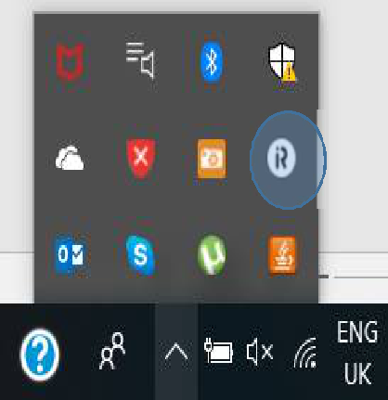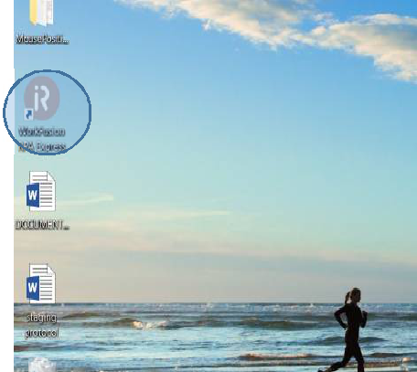

1. After launching application user have to open script file to play recording. It may appear on screen or not. So user must go to window->show view>other.

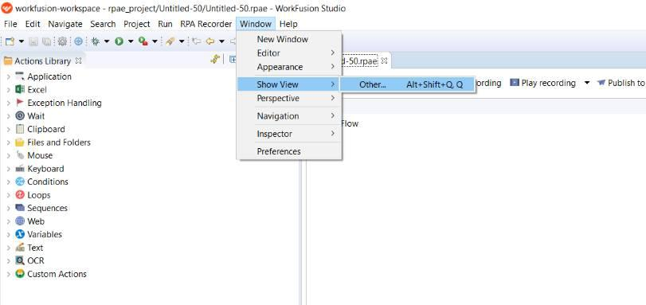

1. A dialog box will appear on the screen. Click on the media files and open it. Media files will be opened in the left side corner.

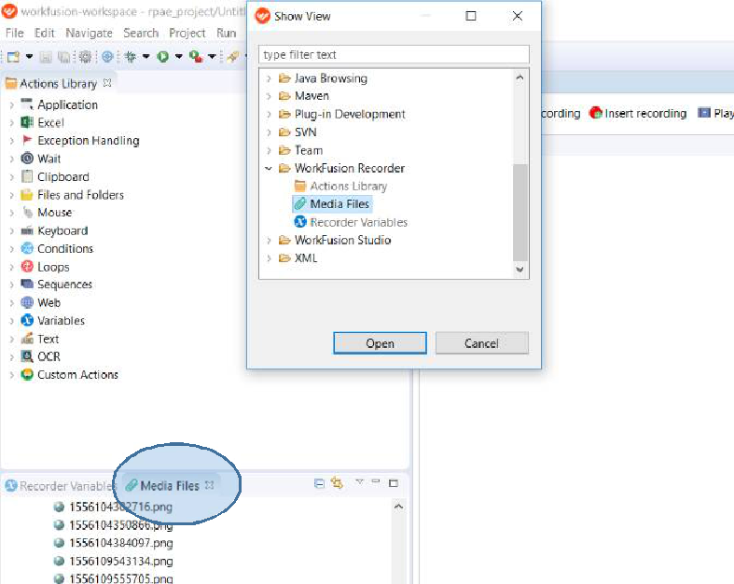

1. Double click on the **automation gif** folder. Then click on the ***gifrec.rpae*** . The file will load on right side.

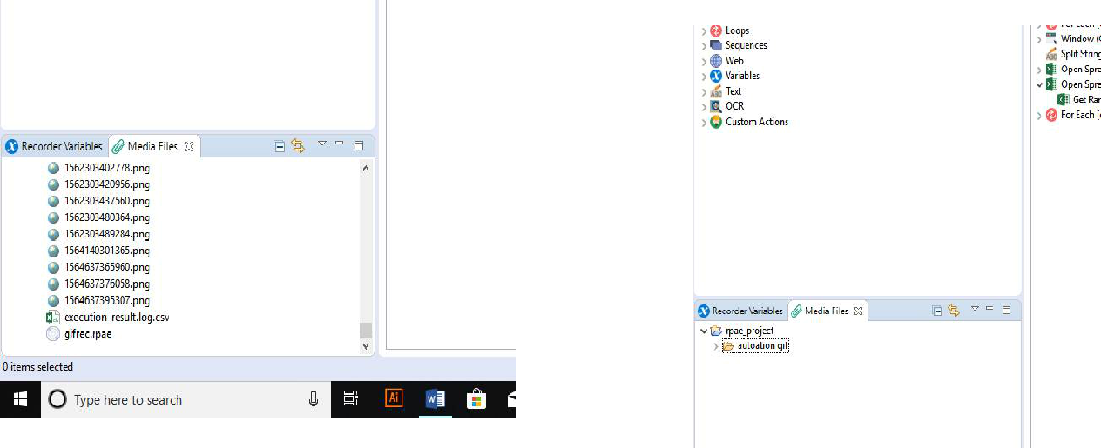

1. Click on the play recording to run the file. After we run the file a small window appears on the right side window.

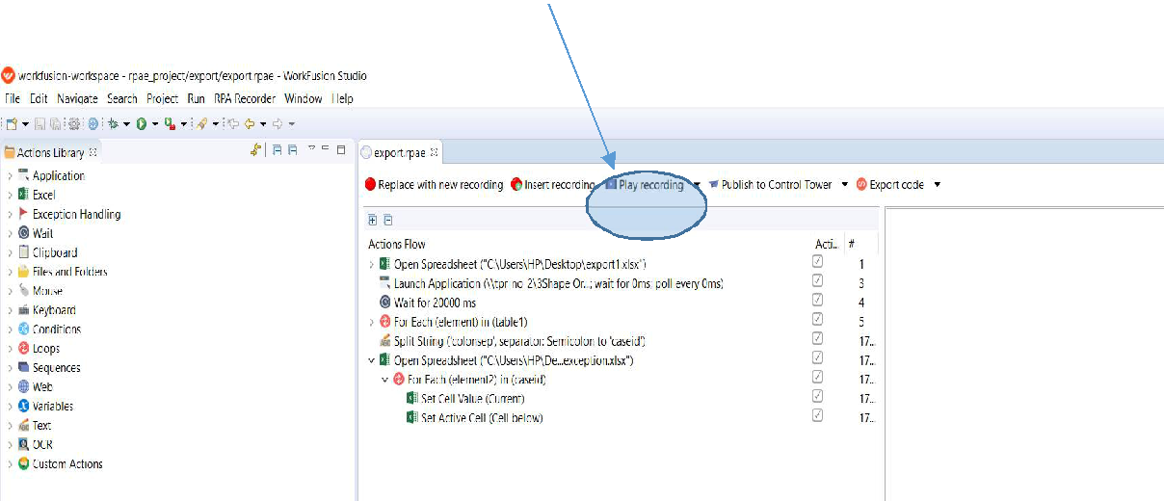

1. The window that appears on the right side must be shifted in upward direction to some extent.

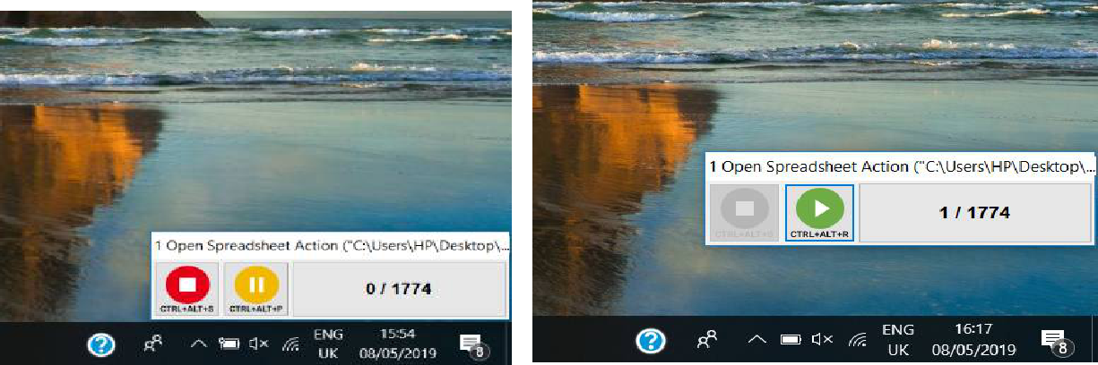

1. Sometimes it may execute an error like couldn’t connect to bot. In that case user must restart bot manager. User must check bot manager is always running

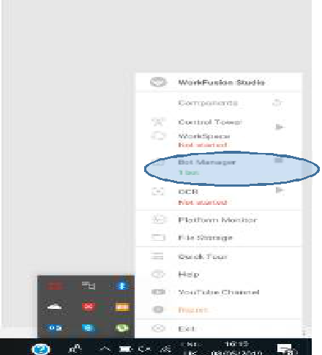

12. User must check the appropriate folders exist in

This pc→local disk(E)→Patient Reports. The name of the folder must be according to given format. The name of patient must be in capital letters with case id. Eg(RAHUL PANCHAL-1904112512). This folder must contain an another folder named GIF-1.

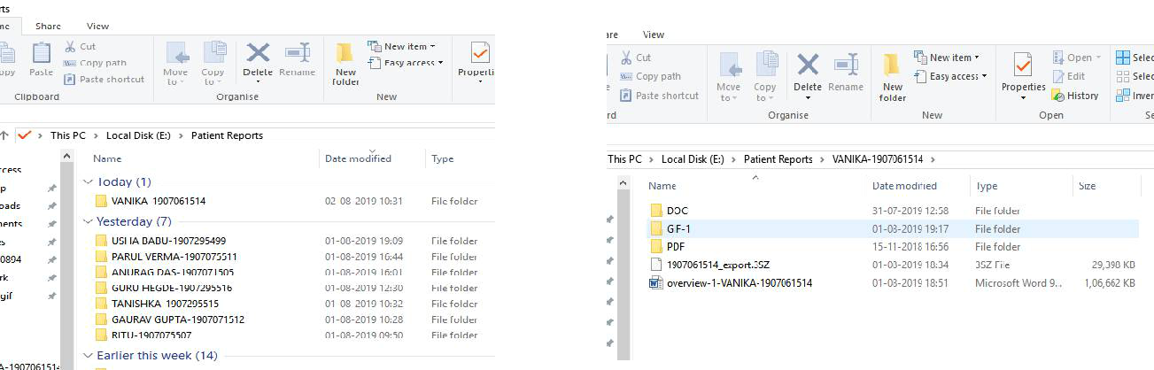

1. Before playing recording user must open the orthodata2 window. All windows must be in maximize mode.

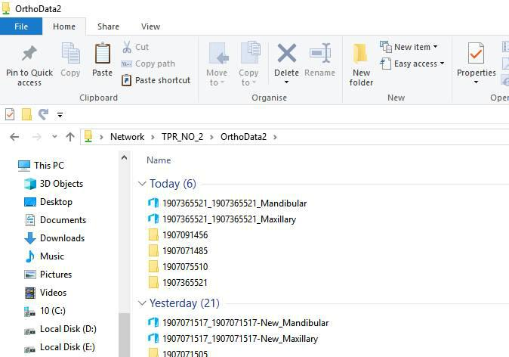

1. The captures and videos folder present under caseid in orthodata2 folder must be empty. It is a must condition for using upload automation.

**UPLOAD/DEFAULT PROTOCOL**

|  |  |
| --- | --- |
| Default | When default plan is exported |
|  |  |
| upload plan | When 1st plan is created |
|  |  |
| upload plan 2 | When 2nd plan is created |
|  |  |
| upload plan 3 | When 3rd plan is created |
|  |  |

1. User must cross check the entries. The entries in orthoanalyzer must be same as mentioned in protocol.

